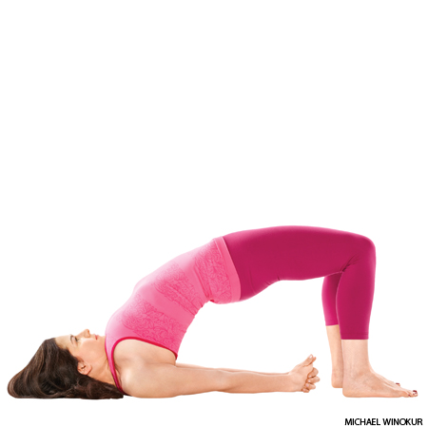

Bridge Pose: Step-by-Step Instructions
Lie supine on the floor, and if necessary, place a thickly folded blanket under your shoulders to protect your neck. Bend your knees and set your feet on the floor, heels as close to the sitting bones as possible.
Exhale and, pressing your inner feet and arms actively into the floor, push your tailbone upward toward the pubis, firming (but not hardening) the buttocks, and lift the buttocks off the floor. Keep your thighs and inner feet parallel. Clasp the hands below your pelvis and extend through the arms to help you stay on the tops of your shoulders.
Lift your buttocks until the thighs are about parallel to the floor. Keep your knees directly over the heels, but push them forward, away from the hips, and lengthen the tailbone toward the backs of the knees. Lift the pubis toward the navel.
Lift your chin slightly away from the sternum and, firming the shoulder blades against your back, press the top of the sternum toward the chin. Firm the outer arms, broaden the shoulder blades, and try to lift the space between them at the base of the neck (where it’s resting on the blanket) up into the torso.
Stay in the pose anywhere from 30 seconds to 1 minute. Release with an exhalation, rolling the spine slowly down onto the floor.
Contraindications and Cautions
Neck injury: avoid this pose unless you are practicing under the supervision of an experienced teacher.
Modifications and Props
If you have difficulty supporting the lift of the pelvis in this pose after taking it away from the floor, slide a block or bolster under your sacrum and rest the pelvis on this support.
Deepen the Pose
Once in the pose, lift your heels off the floor and push your tailbone up, a little closer to the pubis. Then from the lift of the tail, stretch the heels back to the floor again.
Preparatory Poses
- Bhujangasana
- Urdhva Mukha Svanasana
- Virasana
Follow-up Poses
- Bhujangasana
- Salamba Sarvangasana
- Urdhva Mukha Svanasana
- Urdhva Dhanurasana
Beginner's Tip
Once the shoulders are rolled under, be sure not to pull them forcefully away from your ears, which tends to overstretch the neck. Lift the tops of the shoulders slightly toward the ears and push the inner shoulder blades away from the spine.
Benefits
- Stretches the chest, neck, and spine
- Calms the brain and helps alleviate stress and mild depression
- Stimulates abdominal organs, lungs, and thyroid
- Rejuvenates tired legs
- Improves digestion
- Helps relieve the symptoms of menopause
- Relieves menstrual discomfort when done supported
- Reduces anxiety, fatigue, backache, headache, and insomnia
- Therapeutic for asthma, high blood pressure, osteoporosis, and sinusitis
Partnering
A partner can help you learn about the correct action of the top thighs in a backbend. Perform the pose, then have the partner straddle your legs and clasp your top thighs. He/she can brace your outer thighs with his/her inner legs. Next the partner should strongly turn the thighs inward and encourage the inner thighs down toward the floor (as you resist the tailbone toward the pubis). Recreate this action in all backbends.

